**Create a document with screenshots to explain the answer for each exercise**

1. Create a virtual machine with two operating systems, Windows 7 and Windows 10 (in this order). Choose Windows 7 as the default operating system, which will boot after 5 seconds unless Windows 10 is manually selected.

After installing both operating systems, the menu below will appear:

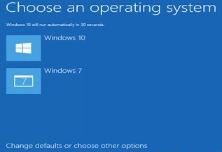

Then, click “Change defaults or choose other options”

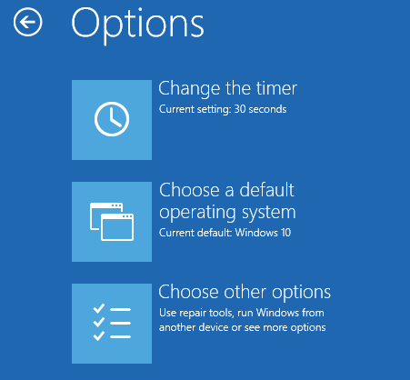

After setting Windows 7 as default operating system, the boot menu will be the classical one from Windows 7.

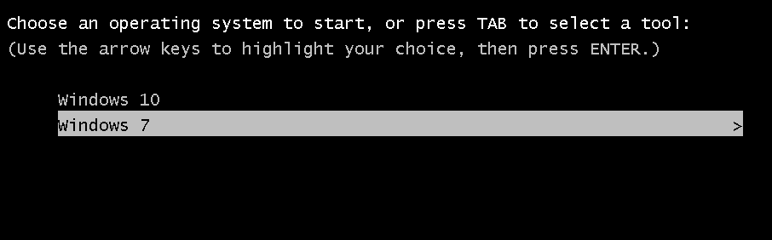

To restore the UEFI Boot menu, we can access from “Settings”, “Update & Security” and “Recovery”

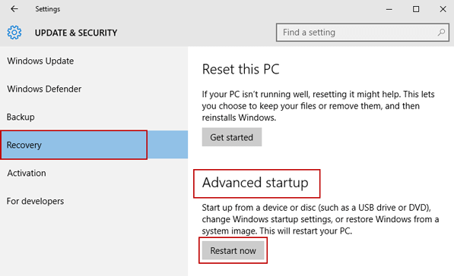

Finally, we can select “Windows 10” as default operating system again from “Use another operating system”

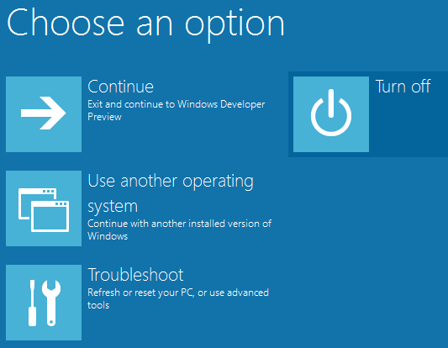

1. Create a virtual machine with two operating systems, Windows 7 (or Windows 10) and Ubuntu 16.04 (in this order) and configure the bootloader to:
   1. Set Windows as default entry and boot after 15 seconds if the user does not select another option in the menu.
   2. Boot Ubuntu without displaying the menu after showing a 10 seconds countdown.
   3. Boot Ubuntu without displaying the menu.
   4. Boot Windows without displaying the menu.

a.

GRUB_DEFAULT=4

GRUB_TIMEOUT=15

GRUB_TIMEOUT_STYLE=menu

The parameter GRUB_TIMEOUT_STYLE is not necessary, since “menu” is the default value

For b, c and d, it is required to comment the following lines in /boot/grub/grub.cfg after running update-grub

# set timeout_style=menu

# if [ "${timeout}" = 0 ]; then

# set timeout=10

# fi

Or the best efficient option (but less safe) is to edit the line below in the file /etc/grub.d/30_os-prober

# adjust_timeout

b.

GRUB_DEFAULT=0

GRUB_TIMEOUT=10

GRUB_TIMEOUT_STYLE=countdown

Another option that is deprecated:

GRUB_DEFAULT=0

GRUB_TIMEOUT=0

GRUB_HIDDEN_TIMEOUT=10

GRUB_HIDDEN_TIMEOUT_QUIET=false

c.

GRUB_DEFAULT=0

GRUB_TIMEOUT=0

GRUB_TIMEOUT_STYLE=hidden

Another option that is deprecated:

GRUB_DEFAULT=0

GRUB_TIMEOUT=0

GRUB_HIDDEN_TIMEOUT=0

GRUB_HIDDEN_TIMEOUT_QUIET=true

d.

GRUB_DEFAULT=4

GRUB_TIMEOUT=0

GRUB_TIMEOUT_STYLE=hidden

Another option that is deprecated:

GRUB_DEFAULT=4

GRUB_TIMEOUT=0

GRUB_HIDDEN_TIMEOUT=0

GRUB_HIDDEN_TIMEOUT_QUIET=true

1. If you lose the bootloader in exercise 2, use the tool “Boot-Repair”, which will let you solve the issue. If necessary, use the following the instructions in the URL: <https://help.ubuntu.com/community/Boot-Repair>

The first option is to use this tool to repair GRUB.

But what is actually happening is that we are hiding the menu. If we type “ESC” as soon as we start the machine, we will finally be able to show the menu to start Ubuntu and modifying the GRUB configuration as a result.